# Sat1 setup second time after LD2450 install

Factory reset.

1. The first reset did not work. The blue LEDs did the countdown. The device did not do anything after that. No LED lights turned on. I waited 5 minutes.
2. Second reset after the blue countdown the LEDs went solid white. After 5 minutes nothing happened. The LEDs were still white.
3. Third reset. LEDs did blue countdown. LEDs flashed white. After 5 minutes nothing happened. No LEDS were on.
   1. The first three attempts were using a USB-C attached to my computer. I checked the voltage in HA before doing the reset. The reading was 5V 3A.
4. Fourth reset. Switched from 5V to 9V PS. The blue LEDs did the countdown. After countdown, LEDs flashed white then LEDs went solid white. After 5 minutes unplugged the USB cable and plugged back in. The LEDs flashed then went solid white.
5. Fifth rest. While holding down the Action button, the red LED countdown stopped at the fourth LED. The LEDs flashed then went solid white.

I could not get past the fifth reset. Every time the red LED countdown would stop at 4 LEDs. So here is what I did next.

1. Plugged the Sat1 in USB-C cable connected to computer.
2. Opened Chrome
3. Went to site <https://web.esphome.io/?dashboard_wizard>

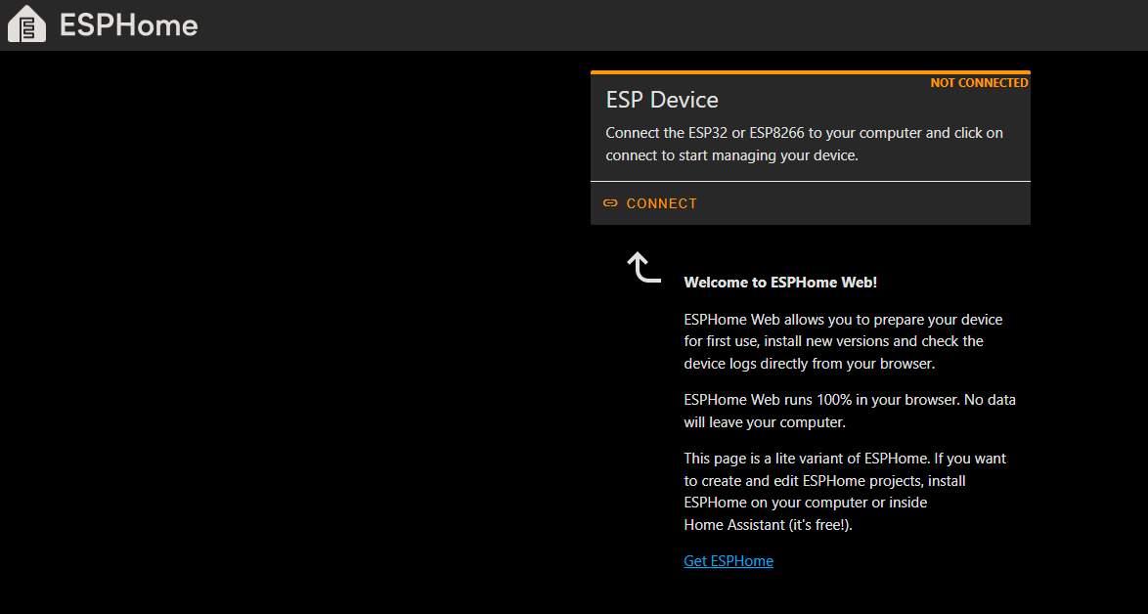

1. Click Connect in ESP Device

1. Next screen clicked Prepare for First Time

1. Click Install

1. Click Close

1. Connected to Wi-Fi

1. Enter Wi-Fi Information

1. Clicked Close then Click Install

1. Downloaded satellite1-esp32s3.factory.bin from GitHub
2. Choose File

1. Click Install
2. Erases device then installs bin file

1. Sat1 booted and then saw sparkling LEDs
2. Followed instructions from website using phone
3. Device setup

I don’t know why the factory reset didn’t work. I figured that I did something to get the device stuck. Lucky, I knew how to use the ESPHome web to setup devices.

LD2450 Setup

1. Take Control

1. Take Control

1. Taking Control

1. Configuration Created

1. Click Skip
2. Click Edit

1. Edit Configuration YAML

1. After uncommented line 27

1. Clicked Save then Install



1. Click Wirelessly

1. Compile and Install Starts
2. Current device firmware

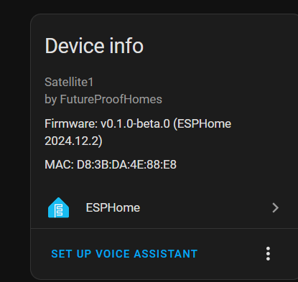

1. There were errors during the compile
2. Log file is attached
3. Had to enable Bluetooth and restart LD2450
4. Current firmware – LD2540 and XMOS are correct now

1. Finished

These are the same steps I performed the first time. The XMOS was unknown until the debug option was installed.